Weight loss will be based on a percentage, not overall pounds.

SMART MTA Wellness Program



Please contact your Wellness Ambassador with any questions.

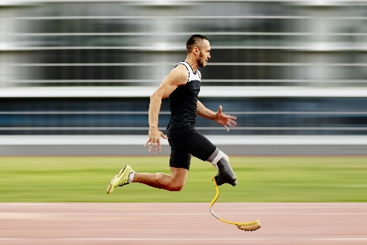

WEIGH-IN

Every other week

START DATE

April 2, 2025

WEIGHT

LOSS CHALLENGE

12 WEEK